# Phonebook App – User Instructions

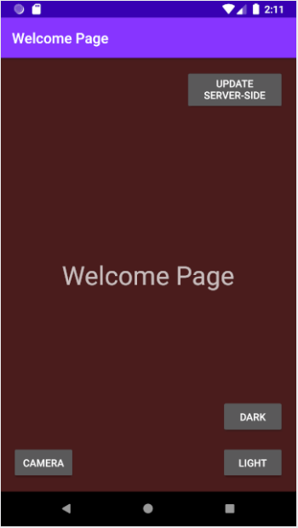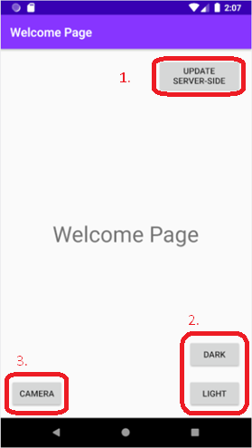Welcome Page

Figure 2. Dark Theme

Figure 1. Welcome Page

1. “Update Server-Side” Button - When this button is clicked, using the Phonebook Web API, it will send the all contacts in the local database to the remote database.
2. “Dark & Light” Buttons – These buttons will change the colour theme of the app
3. “Camera” Button – This button navigates to the Camera Page.

List Page

To navigate to the Phonebook List Page, perform a swipe gesture on the Welcome Page.

1. Alphabetical Navigation Buttons – Click on a letter/character to scroll the phonebook to that letter’s position.
2. Contact – Each contact in the phonebook list can view on the List Page. The user can click on a Contact to naviagte to the Detail Page.
3. Delete Button – To Delete a Contact, the user must Long-Click a contact (press and hold on a contact for over 1 second), a shadow will appear and the user must drag the shadow onto the delete button. A confirmation dialog box will appear and the user must confirm if they wish to Delete the contact.
4. Search Button – Clicking on the Search Icon on the top right corner will open the Search Input box. User can type into the searchbox to search for a contact. Related Contacts will appear on the List Page depending on search input.
5. Sort Buttons – Clicking on the sorting buttons will sort the Contact list in Alphabetically order decending or ascending depending on which button pressed.
6. 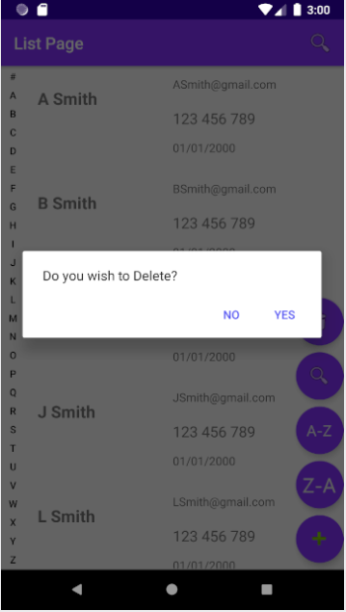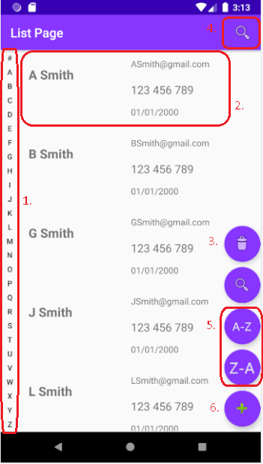Add Button – User can click the Add button to Add a contat to the phonebook. User will be taken to the Add Page.

Figure 4. Deleting a Contact

Figure 3. List Page

Add Page

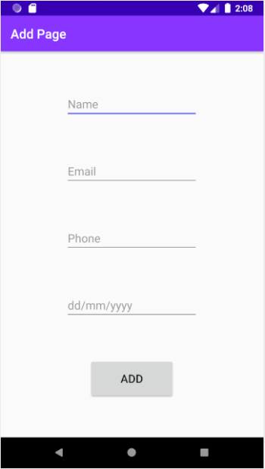User can add a Contact by clicking the Add button on the List Page. When on the Add Page, user can input Name, Email, Phone and Date for the new Contact and then click the add button to add the contact to the Phonebook. After the contact is added, the user will return to the list page.

Figure 5. Add Page

Edit Page

To navigate to the Edit Page, the user must swipe left on the contact they wish to edit, on the List Page. An edit button will be revealed underneath the Contact and the user can click on the edit button to navigate to the Edit Page.

On the Edit Page, user can update the Contact’s details and click the “Update” button to update the contact.

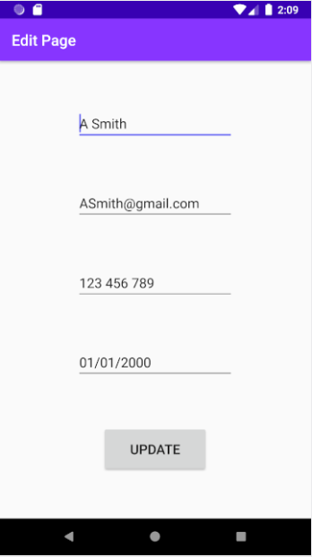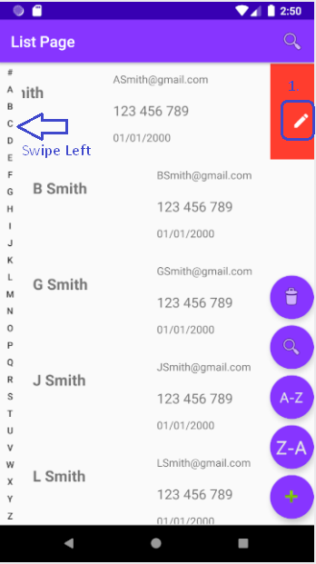

Figure 7. Edit Page

Figure 6. How to Edit a Contact

Detail Page

User can view Contact Details on the Detail Page by clicking on a contact. User will be taken to the Detail Page.

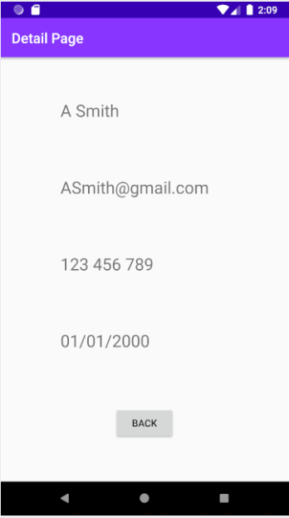

Figure 8. Detail Page

Camera Page

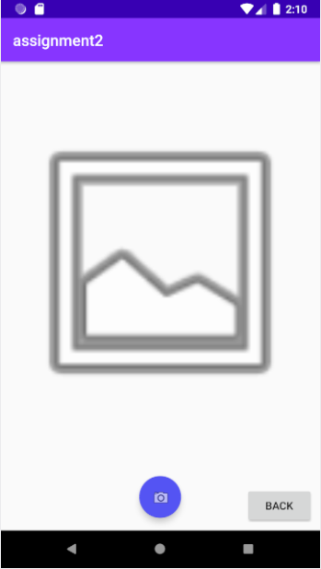From the Welcome Page, user can navigate to the Camera feature by clicking the “Camera” button. When user clicks on the “Camera” button, they are taken to the Camera view page. User can click on the Camera floating action button to access the phone’s camera.

Figure 9. Camera View Page

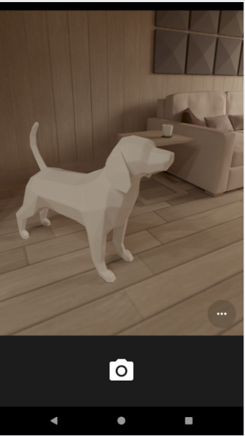

Figure 10. Camera Feature